**Project 2 proposal**

**Group members: Saleha, Erika, Pim, Jasjeet**

**Dataset:**

We will utilise 2 datasets from the public platform Kaggle; the ‘World Happiness Report’ and the ‘Human Life Expectancy Around the World’ report. The World Happiness Report dataset lists information for 158 countries between the years of 2015 to 2021, and the Human Life Expectancy dataset comprises of a collection of 186 countries ranging from 1990 to 2019.

We will focus on extracting the data from 2019 from both datasets for consistency.

The data sources are listed below:

* World Happiness Report 2015-2021 (Kaggle)
  + <https://www.kaggle.com/mathurinache/world-happiness-report-20152021?select=2019.csv>
* Human Life Expectancy Around the World (Kaggle)
  + <https://www.kaggle.com/deepcontractor/human-life-expectancy-around-the-world>

The factors of interest from the World Happiness Report are as follows:

* Freedom to make life choices
* Social support
* GDP per capita
* Happiness rank
* Happiness score

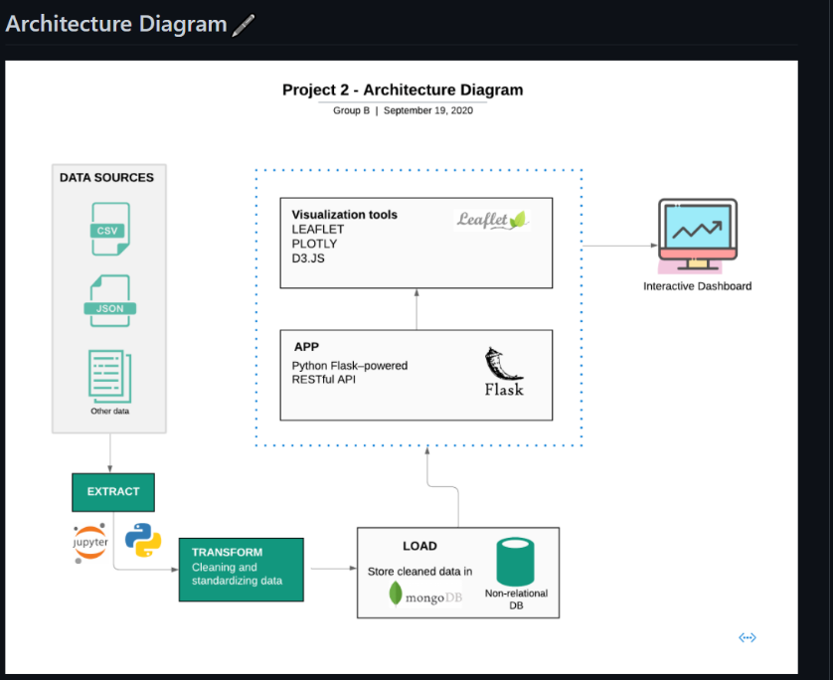**Approach:**

We will load our dataset into SQL database and will use SQL alchemy to render it on the flask app/server. Then we will send this data to the user interface for interactive visualisation using JavaScript, D3/plotly/leaflet.

**Visualisation:**

1. Option to the user to select between happiness factors for a specific country
2. Scatter plot for countries on x-axis and happiness score/happiness rank on y-axis
3. Pie charts for top 10 countries with highest happiness ranking and life expectancy.